SQL Query

Theory:

1. SQL:

Structured Query Language (SQL) is a specialized programming language for managing relational database data. It allows users to store, manipulate, and retrieve data efficiently in databases like MySQL, SQL Server, Oracle, and more.

1. SQL commands:

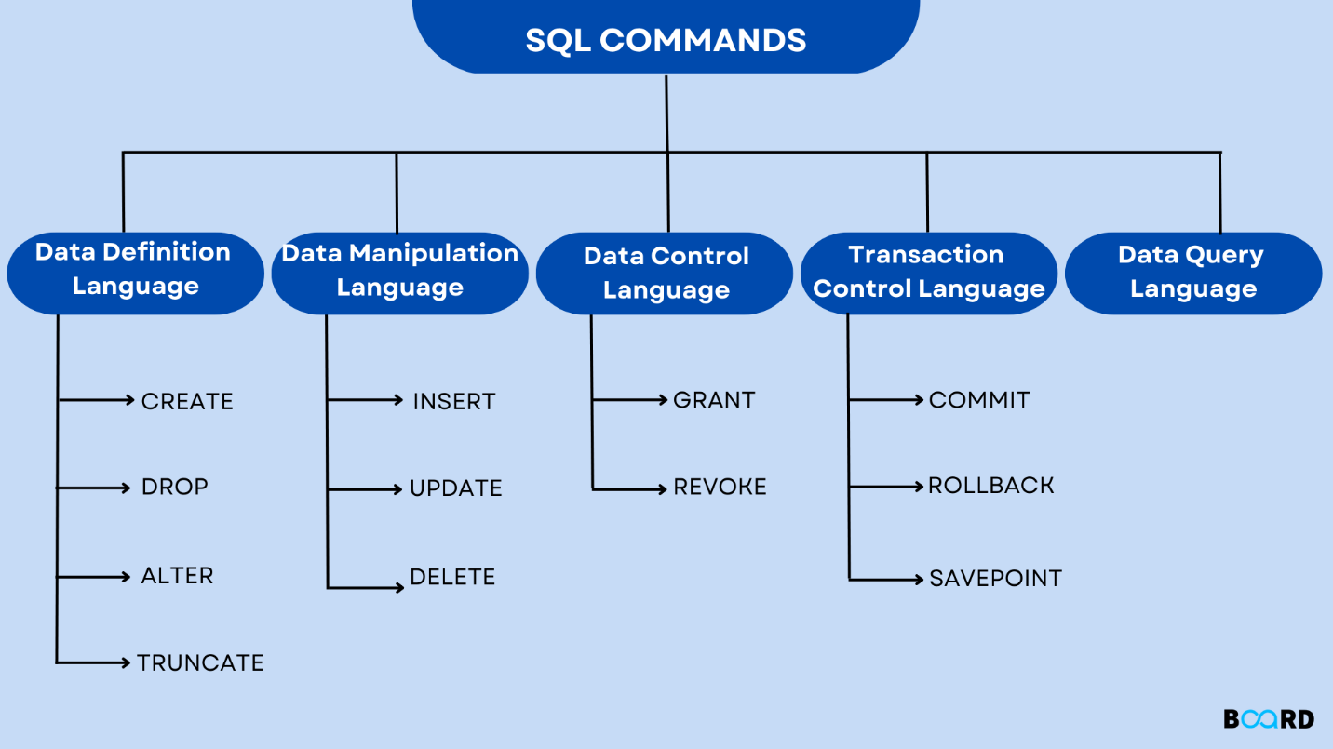

1. Aggregation Function

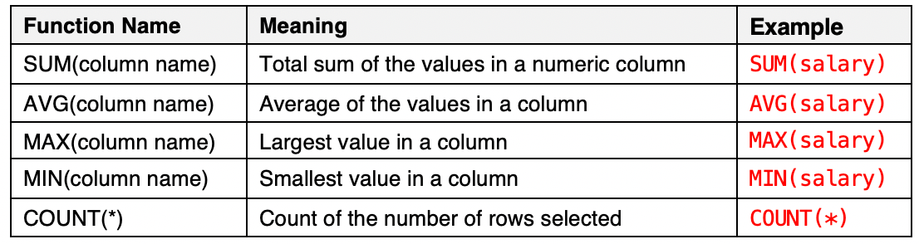

1. JOIN in SQL:

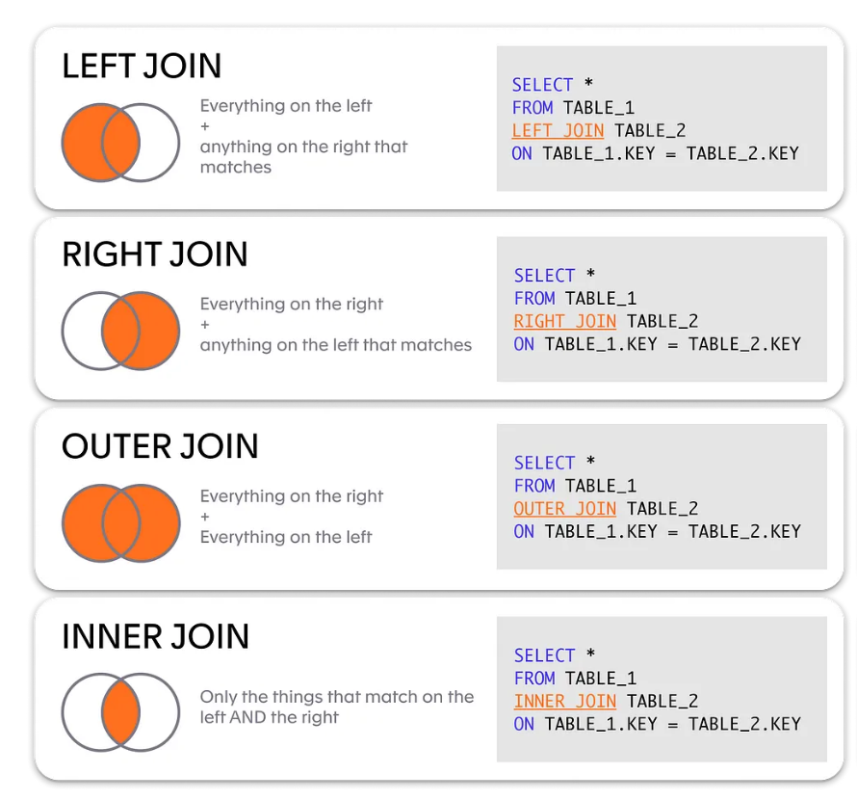

1. SQL LIKE OPERATOR

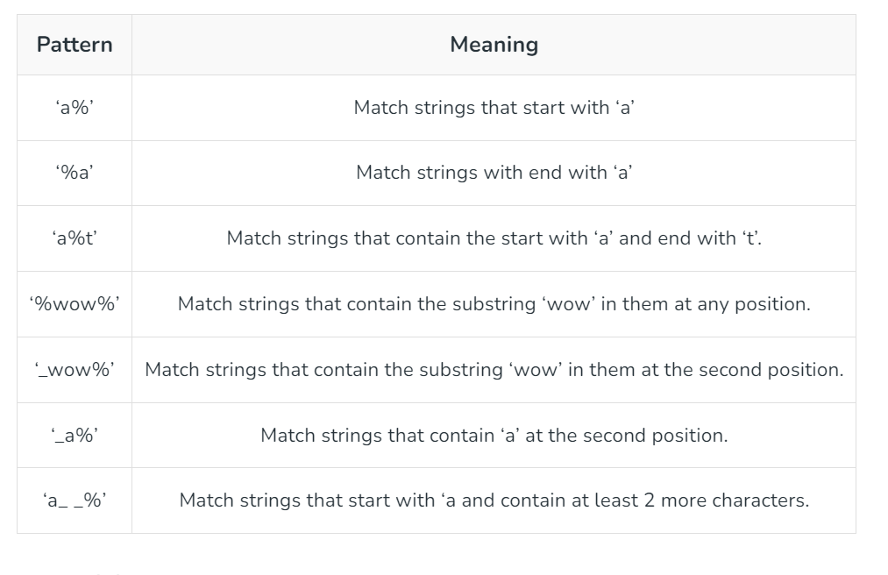

LAB WORK

1. Create a table named Vehicle with veh_number as primary key and the following attributes:

veh_type, veh_brand, veh_year, veh_mileage, veh_owner, veh_photo, veh_price.

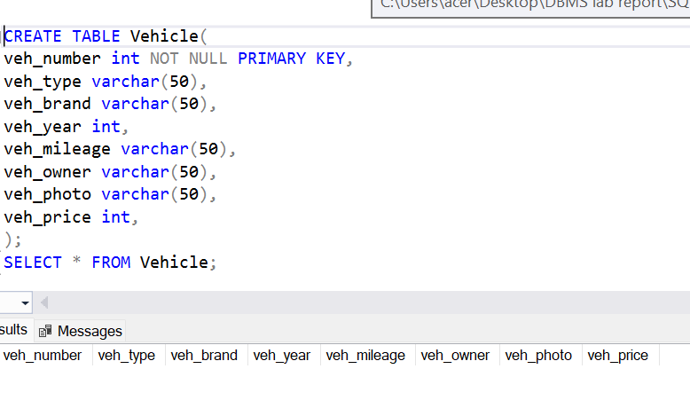

1. Enter a full detailed information of a vehicle.

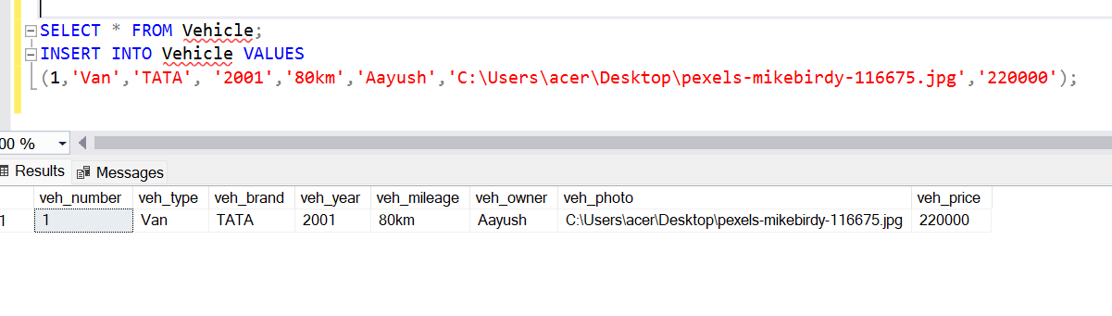

1. Increment vehicle's price by 10,000.

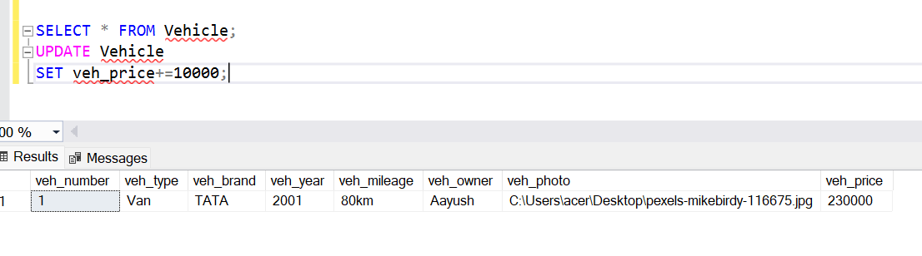

1. Remove all vehicle's records whose brand contains character 'o' in second position.

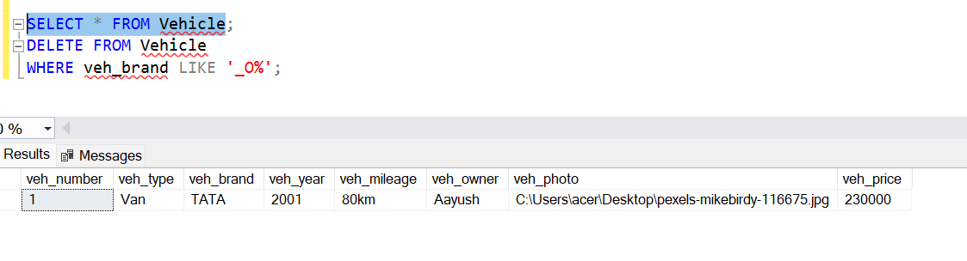

1. Display the total price of all vehicles.

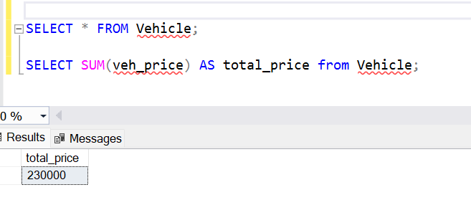

1. Create a view from above table.

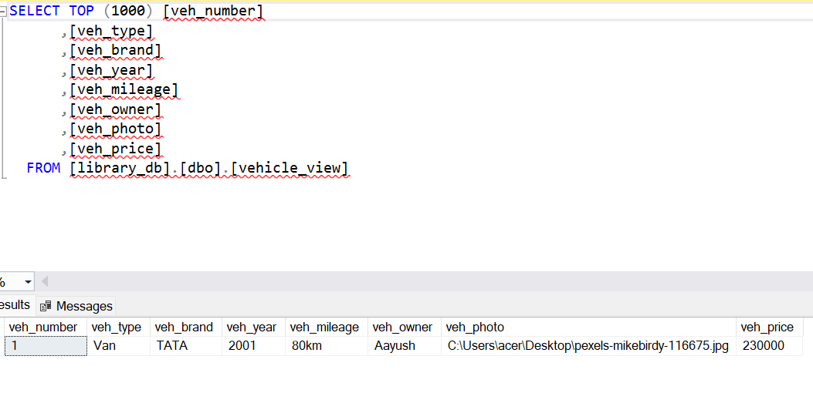

1. Change data type of year to datetime.

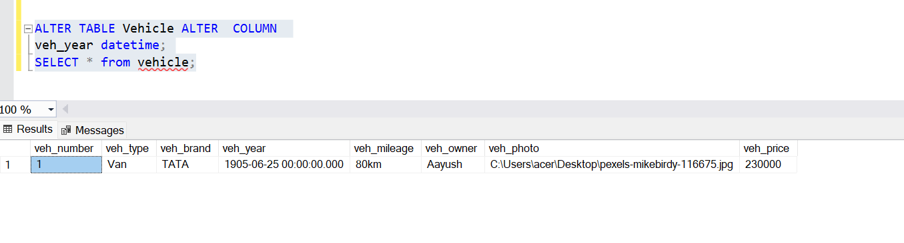

1. Display details of vehicles ordering on descending manner in brand and by mileage when brand matches.

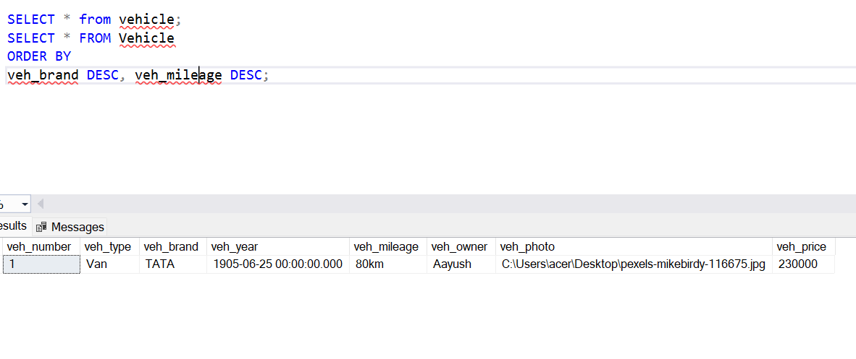

CONCLUSION:

In conclusion, the provided SQL tasks encompass a range of fundamental database operations, including table creation, data insertion, updates, deletions, aggregate functions, view creation, and data type modification. These operations are essential for effective database management and ensure the integrity, accessibility, and organization of data within a relational database system. By mastering these tasks, one can efficiently handle and manipulate data to meet various business and application requirements.